 | Pregnancy and Birth Validation Test - Task 11  Name: ________________________ Date: ___________  _________/ 50 = _____________%  Worth 8% Mark Allocation
Instructions to candidates

Write your answers to the short answer section in the spaces provided beneath each question
Answers that require a numerical answer should show all working out in logical steps.
Candidates should write clearly with a pen unless otherwise directed

- The placenta has many roles during pregnancy. For example maternal and foetal blood are prevented from mixing across the placenta to the foetus.
- State two reasons why maternal and foetal blood should not mix. (2 marks)
- _______________________________________________________________________________
- ________________________________________________________________________________
- List three other roles of the placenta. (3 marks)
- ________________________________________________________________________________
- _________________________________________________________________________________
- _________________________________________________________________________________

- Complete this table by putting ticks in the correct columns regarding the substances that can pass across the placental membrane. (4 marks)
Substance | From mother to embryo | From embryo to mother
Oxygen
Food
Alcohol
Viruses (e.g. HIV)

The diagram below shows a developing foetus in the placenta.  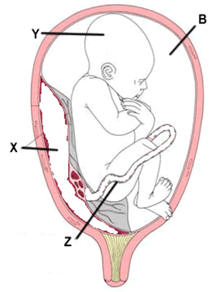 | Label the left diagram. (4 marks)  B: __________________________________  X: ___________________________________  Y: __________________________________  Z: _________________________________

- As the foetus grows within the uterus the females’ abdomen begins to bulge. Describe what you think would happen to the internal organs that are close to the expanding uterus. (2 marks)
_____________________________________________________________________________
___________________________________________________________________________________

Questions 4 and 5 refer to the diagram below.
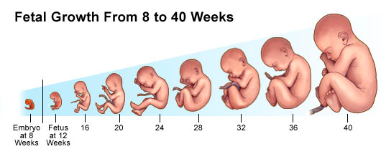

- On the diagram above, label the three trimesters. (3 marks)

- For each of the three trimesters, explain the key events in the development of the foetus.
(6 marks)

Trimester |  | Key Events
1
2
 | 3

- Describe and explain events that take place during each of the THREE stages of the birth process. (3 marks)
- _______________________________________________________________________________
_______________________________________________________________________________
_______________________________________________________________________________
_______________________________________________________________________________
- _______________________________________________________________________________
_______________________________________________________________________________
_______________________________________________________________________________
_______________________________________________________________________________
- _______________________________________________________________________________
_______________________________________________________________________________
_______________________________________________________________________________
_______________________________________________________________________________
_______________________________________________________________________________
_______________________________________________________________________________
- Breastfeeding is recommended for all newborn babies; however in some cases the newborn baby needs to be bottle-fed. Describe THREE advantages for each method of providing nourishment to a newborn baby. (6 marks)
_______________________________________________________________________________________
_______________________________________________________________________________________
_______________________________________________________________________________________
_______________________________________________________________________________________
_______________________________________________________________________________________
_______________________________________________________________________________________
_______________________________________________________________________________________
_______________________________________________________________________________________
_______________________________________________________________________________________
_______________________________________________________________________________________

- A) What is colostrum? (1 mark)
__________________________________________________________________________________
- How does colostrum differ from milk? (1 mark)
_____________________________________________________________________________
____________________________________________________________________________________

- Motor skills are motions carried out when the brain, nervous system and muscles work together. Fine motor skills are small movements – that use the muscles of the fingers, toes, wrists, lips and tongue. Gross motor skills are the bigger movements – that use the large muscles in the arms, legs, torso and feet. Using this information, tick the box for which skills are being developed during infancy. The age of infancy is: _____________________(1 mark)
Infancy development | Gross motor | Fine motor
Plays with fingers at 5 months
Can lift head at 3 months when lying on front
Able to grasp an object at 6 months
Pulls into a standing position at 8 months, holding onto things
Can hold small crayons
 |  | (5 marks)

- Define the term ‘secondary sexual characteristics’ and give two examples for these in the female and two examples in the male. (5 marks)
___________________________________________________________________________________________________________________
___________________________________________________________________________________________________________________
___________________________________________________________________________________________________________________
___________________________________________________________________________________________________________________
Female:
___________________________________________________________________________________________________________________
___________________________________________________________________________________________________________________
___________________________________________________________________________________________________________________
___________________________________________________________________________________________________________________
Male _
___________________________________________________________________________________________________________________
___________________________________________________________________________________________________________________
___________________________________________________________________________________________________________________
___________________________________________________________________________________________________________________

- Females have relatively more body fat than males, and less muscle mass. As a consequence, female sporting prowess has often been overshadowed by that of males. For example, the marathon for women was only added to the events in the Olympic Games in 1984. What changes occur in males during adolescence that result in their greater muscle mass and strength. (4 marks)
___________________________________________________________________________________________________________________
___________________________________________________________________________________________________________________
___________________________________________________________________________________________________________________
___________________________________________________________________________________________________________________
___________________________________________________________________________________________________________________
___________________________________________________________________________________________________________________

END OF TEST

